Literacy  This half term we are reading Gorilla by Anthony Browne. We will be:  - Developing our inference and deduction skills in our reading.  - Recognising key words in our reading and developing our deciphering skills.  - writing letters, stories and reports.  - Recapping on punctuation covered in previous years including capital letters, full stops, exclamation and question marks and in Year 3 and 4, speech marks  - Identifying nouns and verbs in our reading and writing.  - Working on our phonics or spelling patterns.  - Developing our handwriting and joining letters. | Topic  Our topic this half term is called Marvellous Me. We will look at:  Geography: Why is Northumberland is unique?  - Map work looking at countries, counties, cities, town and villages in the UK and in Northumberland.  - The physical and human features of Northumberland.  - Land use in Northumberland.  Why people choose to visit Northumberland.  We will explore these areas through history, art, computing, design technology, outdoor learning, maths and literacy. | Maths  This half term we will all be working on Place Value, number bonds and times tables.  Year 2 will learn to read, write, partition and order 2 and 3 digit numbers.  Year 3 and 4 will learn to read, write, partition and order 3 and 4 digit numbers.  We will all develop our fluency and reasoning and partitioning skills.  We will all make sure we can quickly recall number bonds to 10 and 20 and multiples of 10 that make 100. Year 3 and 4 will look at adding multiples of 100 and 1000.  Year 2 will begin to learn their 10 times tables.  Year 3 will work on their 10 and 5 times tables.  Year 4 will work on their 2, 3, 5 and 10 times tables.
Science  Our science topic this half term is Plants. We will be:  - Learning the names of plants and trees that we can find in our local area  - Naming and describing the function of the different parts of a plant.  - Learning about how plants grow. | 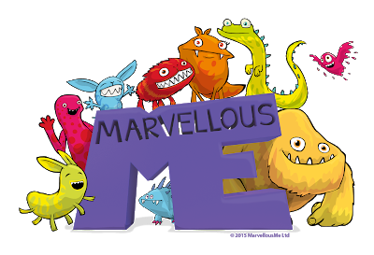  Lapwing Class  Autumn 1 | PSHE  Jigsaw: Miss Swallow will lead our Jigsaw lessons this half term and we will be working on the topic ‘Being Me in My World.’  Fun Friends Resilience Programme: The Fun Friends programme will develop children’s knowledge of theirs and other people’s feelings and how we can manage our feelings.
PE  This half term we will be developing our ball skills in catching, throwing and bouncing. We will play some socially distanced games based on basketball, cricket and rounders. | RE  Our question this half term is: ‘Why is the story of Creation important to Christians?’  We will: Make links between the Bible story of Creation and how Christians behave and treat God’s Creation. | Computing  This half term we will be developing our coding skills using programmes such as Scratch.

