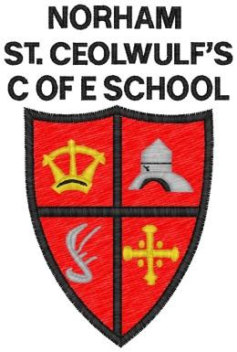 | West Street  Norham  Berwick-upon-Tweed  TD15 2JZ  Tel: 01289 382370  admin@norham.northumberland.sch.uk  Head Teacher: Ms S Jones

Norham St.Ceolwulf’s C of E Controlled First School

Monday 23rd March 2020
Dear Parent/Carer,
Safeguarding during the school closure
I am writing to you in my capacity as the safeguarding lead for the school, to outline how I aim to continue supporting families and children through the school closure due to the COVID 19 outbreak. Even though the school has closed I am available to support and safeguard all young people and to offer advice and support where needed. Please don’t hesitate to contact me if you have any concerns or need advice on protecting or safeguarding a young person.
Whilst this is a generic letter, please be assured I will also make personal contact as soon as I am able with specific parent/carers to hold conversations on how best to support individual circumstances during the closure. Here are the steps the school is taking to support:
• As the school remains open to vulnerable and children of key workers I can be reached through the usual school number of 01289 382370 or by email to sarah.jones@norham.northumberland.sch.uk
• Our pastoral team will continue to check emails and respond to concerns, as well as alert the DSL to any issues.
• In the case of parent/carers currently involved in an EHA process, although we may not be able to meet in person I am exploring the possibility of using email and phone contact to continue to review progress and to support you as best as I am able. I will contact individual parent/carers to make these arrangements.
• If you need to report an urgent concern and for some reason you are not able to contact us - speak to Northumberland’s front door to safeguarding services at One Call on 01670 536400.

Yours faithfully,
Sarah Jones
DSL (Designated Safeguarding Lead)

