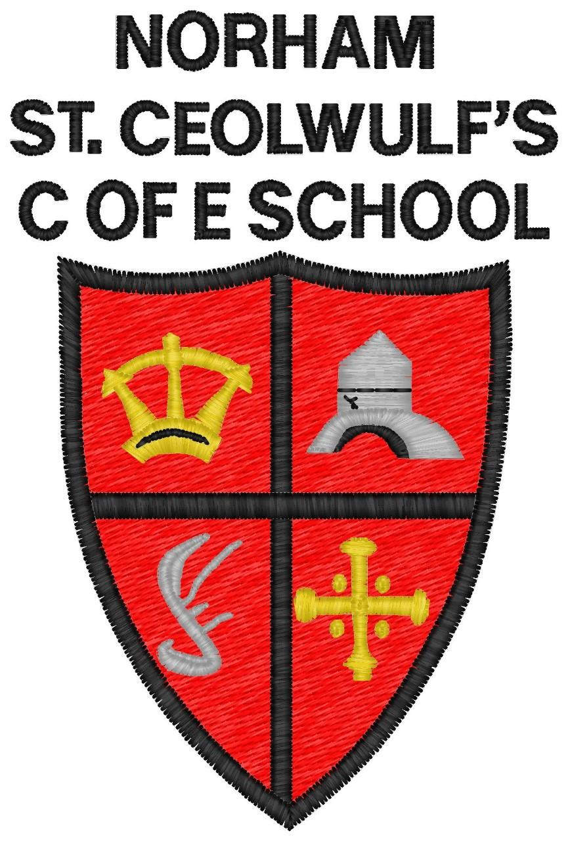

Norham St Ceolwulf’s
C of E First School

Charging & Remissions Policy
2020-2022
Date | September 2020
Date to be Reviewed | September 2022
Head teacher | Ms S Jones
Signed:
Chair of Governors | Mr D Watkin
Signed:

1 Introduction

All education during school hours is free. We do not charge for any activity undertaken as part of the National Curriculum with the exception of individual or group music tuition.

2 Voluntary contributions

2.1 When organising school trips or visits which enrich the curriculum and educational experience of the children, the school invites parents to contribute to the cost of the trip. All contributions are voluntary. If we do not receive sufficient voluntary contributions, we may cancel a trip. If a trip goes ahead, it may include children whose parents have not paid any contribution. We do not treat these children differently from any others.

2.2 If a parent wishes their child to take part in a school trip or event, but is unwilling or unable to make a voluntary contribution, we do allow the child to participate fully in the trip or activity. Sometimes the school pays additional costs in order to support the visit..

2.3 The following is a list of additional activities organized by the school, which require voluntary contributions from parents. These activities are known as ‘optional extras’. This list is not exhaustive:
∙ visits to museums;
∙ sporting activities which require transport expenses including swimming;
∙ outdoor adventure activities;
∙ visits to the theatre;
∙ musical and drama events.

2.4 Materials for practical lessons Voluntary contributions or provision of goods in kind may be requested from parents for materials for practical lessons (Design Technology, Food technology or other subject areas for example), if parents indicate in advance a wish to own the finished product

3 Residential visits

If the school organises a residential visit in school time or mainly school time, which is to provide education directly related to the National Curriculum, we do not make any charge for the education. However, we do make a charge to cover the costs of board and lodging and travel expenses. Parents who receive free school meals are exempt from payment.

4 Music tuition

4.1 All children study music as part of the normal school curriculum. We do not charge for this.

4.2 There is a charge for individual or group music tuition if this is not part of the National Curriculum. The peripatetic music teachers teach individual or small group lessons. We make a charge for these lessons. Parents in receipt of state benefits are exempt from payment. We give parents information about additional music tuition at the start of each academic year.
5 Swimming

The school organises swimming lessons for all children across the school. These take place in school time and are part of the National Curriculum. We inform parents when these lessons are to take place, and we ask parents for their written permission for their child to take part in swimming lessons and a voluntary contribution towards costs. Parents in receipt of free school meals are exempt from payment.

6. Remissions

No charge will be made for such visits other than board and lodging charges. The Governors recognise that they will provide full remission from the charge for board and lodging to pupils whose families are in receipt of the following:
∙ Child Tax Credit ONLY Income below £16,190 (families receiving Working Tax Credit are not eligible
∙ Income Support
∙ Income Related Employment and Support Allowance
∙ Income Based Job Seekers Allowance
∙ Guaranteed Element of State Pension Credit
∙ The Immigration and Asylum Act 1999

Where activities are organised and charged by a third party e.g. independent tour operator, the school may provide for full or partial remission of charges.

