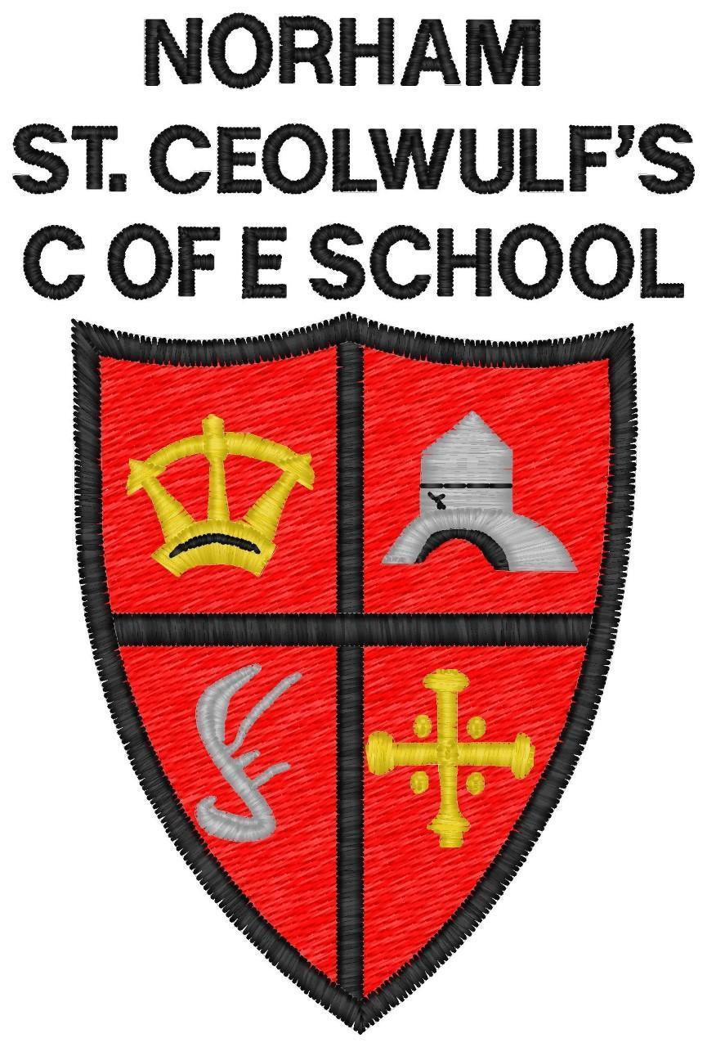

Norham St Ceolwulf’s
C of E First School

British Values Policy
2020-25

Date | June 2020
Date to be Reviewed | June 2025
Head teacher | Ms S Jones
Signed:
Chair of Governors | Mr D Watkin
Signed:

Aim
As a Church of England School (Voluntary Controlled), our Christian Values underpin all aspects of our teaching, learning and school life. British Values reflect these and are promoted ensuring that all members of the school community understand these values which underpin British society.

The teaching of these values of democracy, the rule of law, individual liberty and mutual respect will promote cohesiveness within our school community. We will prepare our pupils for life in Britain where the population has an increasingly rich diversity of backgrounds, origins, beliefs, lifestyles and cultures. By entwining these values with our Chrisitan values, we will help our pupils to become caring, respectful and responsible citizens.

Objectives
- To ensure that all members of the school community develop an understanding of the values which underpin life in Britain.
- To teach pupils to have a mutual respect and tolerance for all people.
- To ensure that pupils have an understanding of the faiths and beliefs represented in Britain today.
- To help all pupils to learn to uphold the rule of law and support freedom, justice and equality.
- To value people’s differences and respect all people regardless of faith, sexual orientation, additional needs, racial and cultural backgrounds.
- To value democracy and to stand up for right against wrong.
- To stand up for those who are oppressed in our society.
- To support those who require extra help.
- To ensure that our pupils become caring, loving, respectful, tolerant members of society.

Strategies
- We will promote British Values through all aspects of our curriculum including through Collective Worship, lessons, PSHE and wider extra curricular activities.
- We will teach children about the history and growth of our country, identifying where changes have been made to make our country a better place for all its citizens and how we can learn from the past.
- We will teach the children about democracy and how it has changed over history.
- We will develop the skills of responsibility within our children, teaching and showing them how we can take care of our world and live in harmony with those in it.

Associated Policies
Equality
SEND
Behaviour
PSHE
RE
Curriculum

