Newsletter

Norham St.Ceolwulf’s First School

sarah.jones@norham.northumberland.sch.uk 27/4/20

Hello everyone,
I hope you are all well and enjoyed last week’s home learning.
I had a virtual meeting this week with the other Berwick head teachers. We discussed transition for Year 4 children to middle school and have started to come up with some ideas to support this. Although it’s too early to make firm decisions, I want to reassure you that we are thinking about how best to support our children.
Please drop me an email if you need anything or want to share what you have been up to for next week’s newsletter.
Take care and stay safe.
Ms Jones
Free School Meals
The Government is currently providing supermarket vouchers of £15 a week to children in receipt of Free School Meals (this does not include Universal Free School meals that all children in EYFS and Key Stage 1 are entitled to). If you think you might be entitled then head over to NCC website and apply: https://www.northumberland.gov.uk/Education/Schools/Meals.aspx
Staying Safe – NSPCC

The NSPCC have produced some guidance for parents and carers to support you and your child including how to talk about Coronavirus with your children and how to take care of your own mental health.

https://www.nspcc.org.uk/keeping-children-safe/coronavirus-advice-suppport-children-families-parents/
What have you all been up to?
It was lovely to receive this email and some photos from Tom and Maddy!

Hi Miss Jones, Maddy and I have been filling our time with lots of gardening and finishing building our pond! We also got a visitor in it called Bob the newt!! Also lots of long walks and bird watching! We are missing our teachers and friends! Hopefully see you soon Tom and Maddy

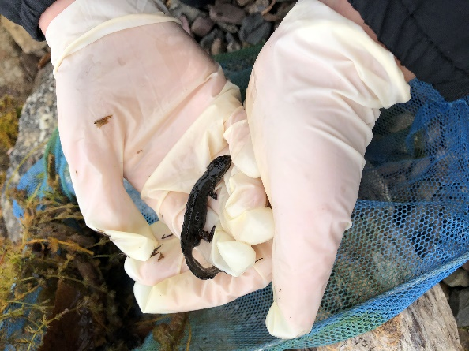

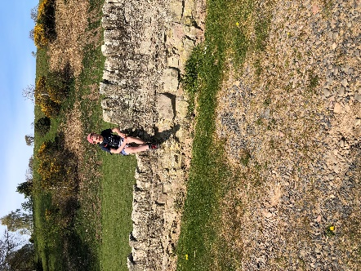
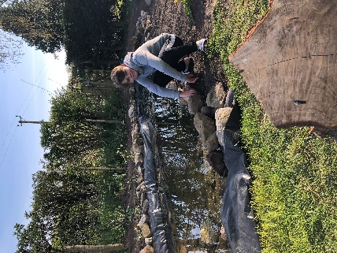

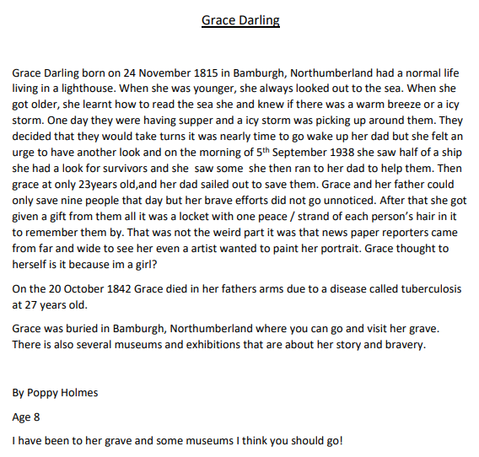
Thank you to Poppy for sending this fabulous biography about Grace Darling.

