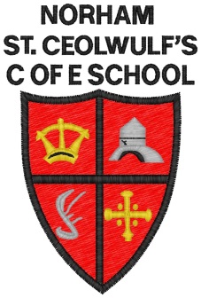
Norham St Ceolwulf’s C of E First School
Collective Worship Overview 2018/19
Each term, our Collective Worship has a Christian values theme which corresponds to the Roots and Fruits Collective Worship scheme. During the week different people celebrate and lead Collective Worship including Ms Jones, Rev Kelsey and the Open the Book team from our village parish.

Term | Theme
Autumn 1 | Thankfulness  Celebrating: Harvest
Autumn 2 | Trust  Celebrating: Advent
Spring 1 | Perseverance  Celebrating: Epiphany
Spring 2 | Justice  Celebrating: Lent and Easter
Summer 1 | Service  Celebrating: Pentecost
Summer 2 | Truthfulness  Celebrating: Trinity

