Lapwing Class Home Learning - Week Beginning Monday 27th April

Hello,

How are you all? I hope you enjoyed last week’s learning – it was great to see photos of you keeping busy and learning in all sorts of different ways.

Remember, this work is here to help you and you can do as much or as little as you can manage. The most important things are to read, practise times tables and do a little bit of writing.

If you need any support with work, want to share work with me or want some feedback then just email it to me at: sarah.jones@norham.northumberland.sch.uk.

Thank you for all your hard work. Please take care and stay safe.

Ms Jones

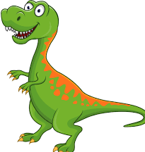
This week’s theme is
Dinosaurs!

(I bet you can guess who picked this!)

Literacy
Spelling: This week we are learning to spell words that end in -al.
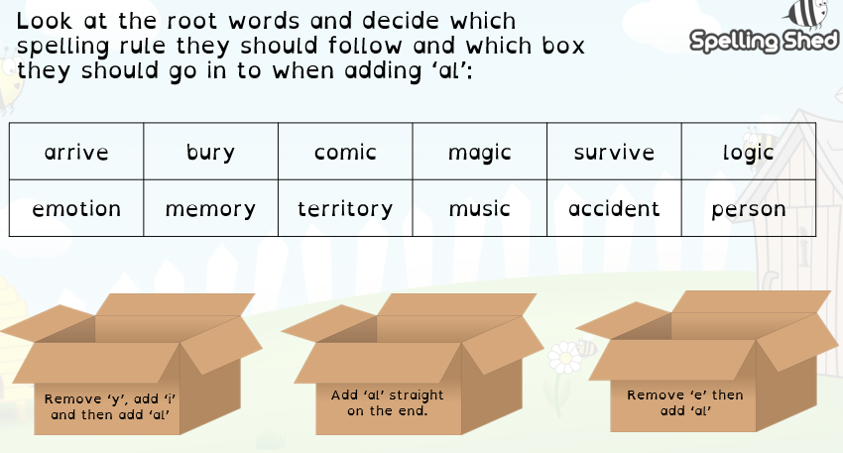
1)

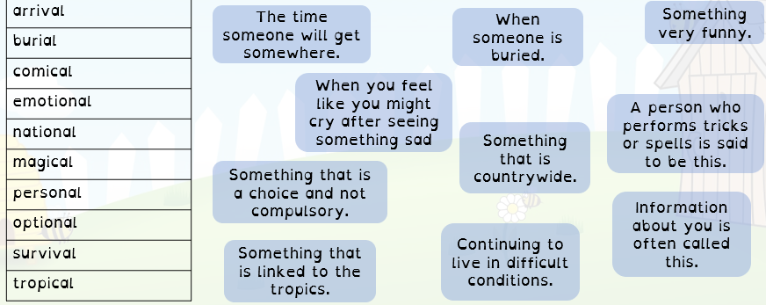
2) Can you match the definition to the ‘al’ word?

3) Choose 5 words and put them into a sentence. Can you start each sentence with a fronted adverbial e.g. a word that ends in -ly?

I trace a word upon your back: This is a great activity to help you practise spellings from your list. You will need someone to do this with (if you’ve got a sibling you could do this with each others spellings). Take it in turns to draw each letter of your word onto your back, the person being drawn on writes down each letter to spell the word. You could use your spelling list at first and then gradually take it away.
Word Work – This week I’d like you to find out more about nouns.

Before you watch the video, have a think about what you think a noun is.

Follow this BBC Bitesize lesson on nouns and complete the activities - https://www.bbc.co.uk/bitesize/articles/zjrdwty
Reading: Fossils

- Read the attached sheet about fossils. Highlight any interesting vocabulary. Remember to find out what any new words mean using a dictionary.
- Answer the questions on the attached sheet (underneath the text) in your work book in full sentences.

SUPPORT: Some children may need help to read the text or even need it reading to them. Please do this if you need to. Enjoy the text together.
Writing: This week I want you to write a short story featuring dinosaurs or fossils.

It’s time for a little story writing! Your story must include some link to dinosaurs or fossils. Possible ideas could be:

- A story set in prehistoric times with a dinosaur as your main character. Maybe your dinosaur gets split up from the others and has to find its way back home?
- A story set today where some children find a real life dinosaur which they sneak into their house to keep as a pet. Think of the trouble it would cause!
- A story where a child finds a dinosaur fossil whilst on holiday. Do they become rich as it is a very rare dinosaur? Is the fossil magic and transports them back in time?

PLANNING
Before you start writing you will need to plan your story!

Opening – How will you hook your reader into your story?
Build up – How will your character ‘get to’ the problem?
Problem – What goes wrong for your main character?
Resolution – How do you solve the problem?
Conclusion – How does your story end.

WRITING
When you write your story remember to:
- Organise your writing into paragraphs (use your planning sections to help you with this)
- Punctuate your sentences correctly with capital letters, full stops, question marks, exclamation marks, commas and speech marks.
- Include some exciting vocabulary.
- Include speech.

EDITING AND IMPROVING
When you’ve finished your story, put it to one side for a day. Come back to it and read it through checking it makes sense, that you’ve spelled common words correctly and that you’ve punctuated correctly. Can you make any improvements e.g. changing or adding a word?

FINALLY
You might want to add an illustration to your story or even turn it into a mini book.
I’d love to see what you’ve done to so email your stories across!

Maths
Times Tables: This week I would like you to practise your 9 times tables!

- Dance and sing your 9 times table with the Rapping Unicorn! https://www.bbc.co.uk/teach/supermovers/ks2-maths-the-9-times-table/zr2gt39

- Learn how to do the ‘9 times table trick’ by following this video – maybe you could make a video of your own explaining how it works! https://www.youtube.com/watch?v=_qmYcvChQwo

- Use Times Table Rock Stars to practise your tables.
Column Subtraction: This week I would like you to practise your column subtraction method.

- It’s always good to recap those mental addition and subtraction strategies. Use this Supermovers video to do that: https://www.bbc.co.uk/teach/supermovers/ks2-maths-mental-addition-&-subtraction/zj9pwty

- Watch this video to recap the column subtraction strategy: https://www.bbc.co.uk/bitesize/topics/zy2mn39/articles/zc78srd

- Have a go at the calculations below using the column method. They get more challenging as you work through them!

a) 87 – 43 =  b) 95 – 20 =  c) 245 – 132 =  d) 848 – 517 =  e) 654 – 302 =  f) 8745 – 5631 =  g) 4321 – 3211 =  h) 9835 – 7520 =  i) 5678 - 3056=  j) 2549 – 1328 = | a) 765 – 347 =  b) 543 – 316 =  c) 785 – 349 =  d) 7543 – 2128=  e) 9858 – 4530=  f) 6743 – 3481=  g) 5825 – 2562=  h) 6431 – 3250 =  i) 5134 – 3612 =  j) 6319 – 4704= | a) 456 – 278=  b) 781 – 693 =  c) 542 – 173 =  d) 4896 – 3907=  e) 7421 – 6569=  f) 6089 – 4791 =  g) 4803 – 1756=  h) 1608 – 379 =  i) 6321 – 567 =  j) 8083 – 592=

Reasoning and Problem Solving Question!
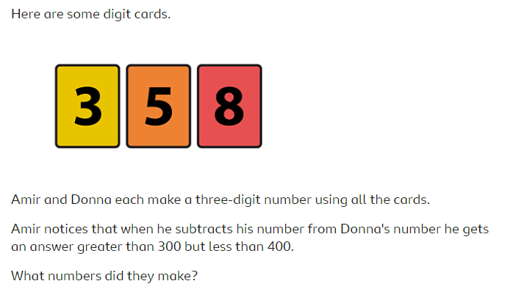

Challenge: can you make a poster or a video (or both) to explain how to carry out a column subtraction calculation? Think about:

- How we set out the calculation.
- Each step in the calculation.
- How we borrow and why.
- What common mistakes might people make?

Perimeter: This week I would like you to learn how to calculate the perimeter of a rectangle.

1) Watch this BBC video all about finding the perimeter: https://www.bbc.co.uk/bitesize/topics/zvmxsbk/articles/zsr4k7h

When I think of perimeter, I think of an ant walking all the way around the outside of my rectangle – how far has the ant travelled?

2) Have a go at calculating the perimeter of the rectangles below:
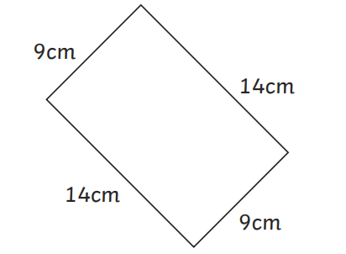
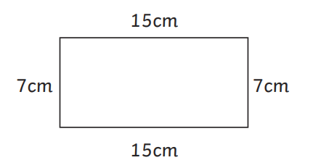
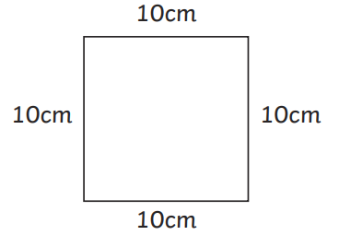
Reasoning and Problem Solving Question!
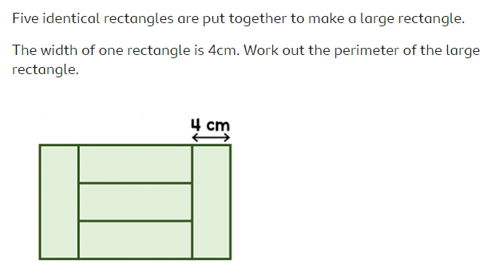

Challenge: Can you find the perimeter of other items in your house e.g. books, tables, doors, even your garden!

Wider Curriculum - suitable for everyone!
Assembly: Follow the link below to watch this week’s Picture News assembly which is all about how travel has decreased during the lockdown and asks the question: Do you think people will travel less in the future?

Video assembly: https://vimeo.com/407559266

Watch the video together and discuss the questions as they are asked.

Collective Worship
This week’s Collective Worship story is the parable of The Good Samaritan.
Watch this video of the story: https://www.bbc.co.uk/bitesize/clips/z4vcd2p
Talk about how the Samaritan helped a stranger in need. Who is being helpful at the moment? How can we be more helpful?
PSHE – This week’s PSHE activity is linked to our emotions, how we manage these and finding ways to be positive.

Note to parents: This is an unusual time for everyone and I’m sure we all have worries about what is happening in the World and this includes our children. It is important to remind children that it is OK to be worried and to feel overwhelmed, scared and sad and to share how you are feeling to – they don’t need us to take their worries away, we just need to acknowledge them and let them know we are here to listen and help them.
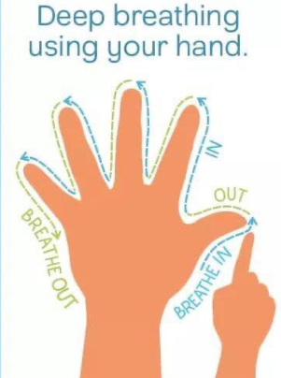
1) Hand Breathing – We’ve practised this technique in class and it’s great as a calming exercise at any point in the day or when your child is feeling anxious or angry. Practise it together.

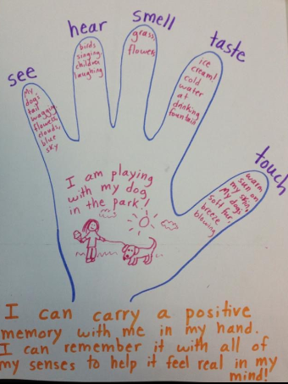
2) Positive Hand – Complete the activity below. Draw a hand (it needs to be quite large to fit the writing in) and label each finger as one of your senses. Think about a place that makes you feel happy and write down what you can see, hear, smell, taste and feel in this place. Display the hand and encourage your child to remember their ‘happy place’ when they feel worried or sad.

3) Have a go at some yoga with Cosmic Kids Yoga – this one is based on dinosaurs!
https://www.youtube.com/watch?v=BqtPZ9OKa94

Thrive: attached to this email is a list of Thrive activities you can do with your child during the week to support their social and emotional development.
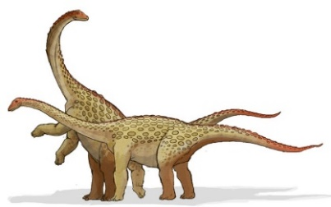
Science - Dinosaurs
https://www.sciencekids.co.nz/dinosaurs.html
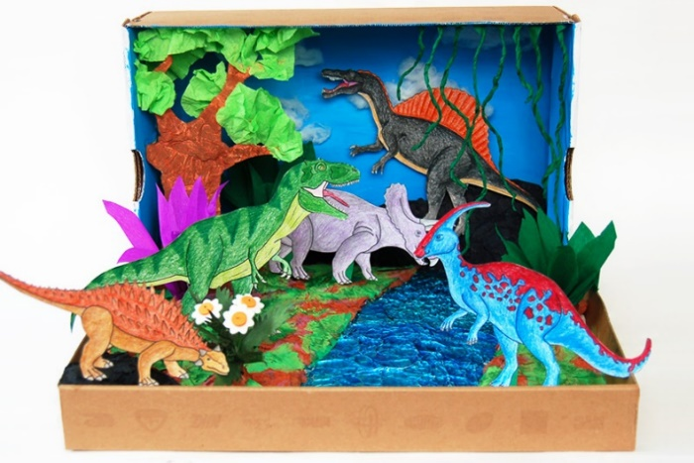
I found this very good webpage which has links to dinosaur facts and some things you could have fun with too while you learn a bit more about these creatures. Make sure you dust off your dinosaur toys and models at home this week to play with too. A dinosaur diorama is an excellent way to display any pictures, backgrounds or dinosaur toys you may have at home.

Here’s a link to a film clip which gets us thinking about dinosaurs and the fossils they created.
https://www.stem.org.uk/resources/elibrary/resource/36611/fossils

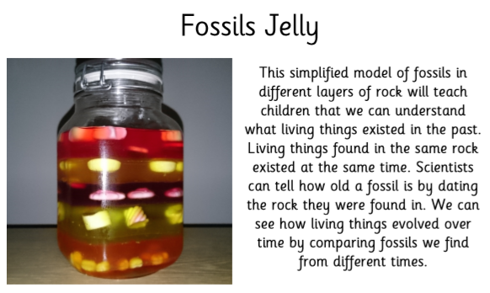
If you are looking for an excellent and yummy way to remind your brain how fossils occur in layers then try this fossil jelly experiment. I’m sure you could use coloured water and ice if the shop runs out of jelly! You will need to add layers of jelly, allowing them to set one layer at a time and as you do, pop sweeties in to represent the prehistoric fossils which were laid in layers of rock over millions of years.
Art:
Let’s create our own dinosaur fossils!

You will need: 250g of flour, 125g of table salt and 125ml of water.

Instructions:
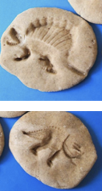
- Mix together the flour and salt.
- Carefully add the water little bit at a time until it is a dough. Add more water if it doesn’t stay together very well or add flour if it is too sticky.
- Knead the dough together with your hands, roll into small balls (about the size of your hand).
- Flatten the balls using your hand or rolling pin.
- Press objects into the dough to create lines and marks (that look like prehistoric bone marks).
- Leave to dry or place it in the oven (on lowest temperature) until hard (the thicker they are the longer they take to dry out).
- You can now paint the fossils.

Let’s build a garden dinosaur!
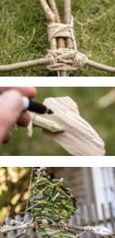
You need to collect: bendy sticks, string, some plants to weave and anything else you fancy.

Instructions:
- Using the bendy sticks and string carefully bend and tie them to create the shape of your dinosaur.
- Add more sticks and string to create the body.
- Weave plants, flowers and leaves through the string and sticks on the body.
- Add objects such as sticks, stones or leaves for the head or feet.
- You can add any detail such as a face with pen (permanent marker may be best).
- Add string and hang from tree or gate.

