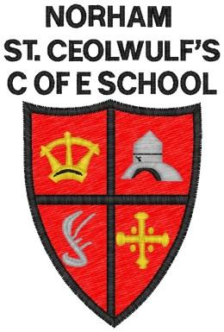 | West Street  Norham  Berwick-upon-Tweed  TD15 2JZ  Tel: 01289 382370  admin@norham.northumberland.sch.uk  Head Teacher: Ms S Jones

Norham St.Ceolwulf’s C of E Controlled First School

Friday 20th March 2020
Dear Parents and Carers,
Tonight your child has bought home a ‘Learning Pack’ which includes a wide range of tasks and activities to support your child’s education at home. This is a very unusual situation we are in so we will continue to provide as much support as possible by posting links to websites that are offering free access to resources and other learning activities. It is heart-warming to see so many businesses making resources available to support us all.
The purpose of closing schools is to help prevent the spread of the Covid-19 virus (coronavirus) and, as we all know, illness in schools spreads quickly. Although children appear not to become as ill if they contract the virus, they do have the ability to pass the virus onto to others, including those who are most vulnerable.
In order to support those essential organisations that are key to supporting the country during this time, we are offering childcare for keyworkers (these families have been identified and spoken to). This childcare is only provided when keyworkers are at work and are unable to find appropriate childcare. Parents are expected to care for their child when not in work in order to help prevent the spread of the virus. Medical guidance on self-isolation with symptoms still applies.
It is important that we all remember that these are challenging times. The closure of schools is an unprecedented step in order to help prevent the spread of the virus by limiting the gathering of groups. Please follow Government guidance and, where possible, limit the contact you and your child have with others.
Finally, can I thank you all for your support and understanding during what has been a very challenging week and can I say thank you to all of the staff who have offered their support in whatever way they can including offering to work during what would have been the Easter Holidays in order to support our key workers. Please do keep in touch with us and I will keep you updated through text messages, the Facebook page and website with any news as I get it

Ms Jones

